- Roadmaps:
  - Roadmap.sh
  - Roadmap.sh/ai/
    - Create roadmap of any other profession
- ClassCentral.com
  - Free online courses to build resume

- Online market and sales tracker:
  - Particl AI tracks sales, inventory, pricing, assortment, and sentiment across all of e-commerce. Quickly identify profitable opportunities in the market. Particl AI Tracking. By collecting primary data from 70K+ e-commerce companies, Particl not only provides high-level insights on market trends; but also specific data on product sales volume down to the very SKU.
  - https://www.particl.com

- Local Fruit sales services:
  - This entrepreneur in Canada makes $50K/month by buying fruit in bulk, slicing and dehydrating it, then packaging it for cocktail bars and online customers 🍋
  - https://www.instagram.com/reel/DSxjnIQDTbD/

- Instagram automation:
  - https://www.instagram.com/reel/DR-hZCwDp03/
    - Braden.io
    - Whop: $3.50 per 1000 views
  - https://www.facebook.com/reel/686226240981173
    - Pick a niche you care about, then join Digistore24 and choose one high-payout digital product ($500–$1K+ per sale).
    - Put your affiliate link into a simple funnel or landing page.
    - Post short 4–7 second scroll-stopping videos on TikTok/IG daily that drive traffic to the link.
    - Stay consistent, improve hooks that work, and scale what converts.

- Free AI alternatives
  - https://www.instagram.com/reel/DSm4UxQiaAZ/
    - Text: Deepseek
    - Video: KlingAI
    - Image: Leonardo or Lexica
    - Video edit: Insta edits
    - Avatar Creation: Hedra
    - Voice: Speechma
    - Music: MusicFX
    - GPT: ORA
- Free app alternatives
    - Movies: VUDU
    - Music: AudioMark
    - PremierePro: Kdenlive
    - Lightroom: Darktable

- Entrepreneur businesses Ideas:
  - https://www.instagram.com/reel/DQyo-tTASYQ/
  - Free papers on disruptive markets
    - Access free reports from McKinsey, BCG, PwC, Bain, and Deloitte
    - Identify recurring trends and fast-growing industries
    - Spot gaps, inefficiencies, and unmet needs
    - Act early while corporations are still analyzing
    - Build focused solutions around those insights
    - Scale as the trend gains momentum
    - Key idea: The data is public — execution is the real advantage.

- Houses Section 8
  - Choose city in a landlord friendly state: https://mastermultifamily.com/renter-friendly-vs-landlord-friendly-states/
  - Step 2: Go to Realator.com
    - Filters:
      - Max $100K
      - 3+ Bedrooms
      - Max 1500 sq feet
      - Less than 100 years old
      - House
    - Choose house, turn-key: get occupied with tenant immediately after closing
  - Step 3: SpotCrime.com
    - Make sure no major crime in the area
  - Step 4: Huduser.gov
    - Get the FMR
      - Section 8 Tennent guaranteed monthly rent by zip code
  - Step 5: Deal Calculator
    - 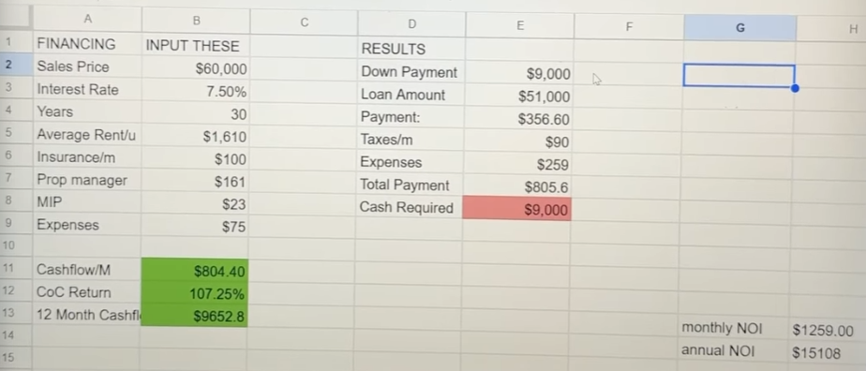
  - Step 6: Can fund all of this using a DSCR load
    - Loan simply on the estimated return the property is going to make

- Websites for local Businesses
  - https://www.facebook.com/reel/1405210681186868
  - Landingsite.ai
    - Go to google maps, find business that has good reviews but no website
    - Copy the first couple of reviews and paste to this
      - Give me a prompt I can paste into LandingSite.ai to build a mad-sexy, luxurious, high-converting website for a business called [COMPANY NAME], who currently has no website. Use these reviews to shape the voice, credibility, and selling points: [PASTE REVIEWS HERE]. Make the final site feel expensive, modern, cinematic, and instantly trust-building so visitors want to buy or book immediately!
    - Go to LandingSite.AI add name of business and the GPT description
    - Setting, client sharing and client link:
      - Direct Response Marketer

- Content
  - 5 types of content every creator should make:
  - https://www.facebook.com/reel/1821364971911520
    - Educational – Teach something valuable that helps your audience learn or solve a problem
    - Double Downs – Repeat and refine content formats or topics that already perform well.
    - Social Proof – Showcase results, testimonials, or examples to build trust and credibility.
    - Storytelling – Share narratives to make content memorable and emotionally engaging.
    - Series – Create multi-part or recurring content to keep audiences coming back and increase retention.

- Trend discovery & market research tool
  - ExploringTopics.com
    - Identifies rising trends before they go mainstream
    - Analyzes search data to spot early momentum
    - Helps creators and product builders act before markets get saturated
    - Supports content, SEO, and product strategy decisions

- Content repurposing & internal linking SEO workflow
  - AnswerThePublic.com + ChatGPT + Google Search
    - Find real questions people are asking about your service
    - Use ChatGPT to generate a tailored, expertise-driven blog post
    - Add case studies, experience, and unique insights
    - Publish the post and internally link to 3 relevant pages
    - Use site:yourwebsite.com "keyword" to find linking opportunities
    - Add 3 backlinks from existing pages to the new post
    - Strengthens SEO and topical authority in ~30 minutes

- AI-powered short-form video creation platform
  - Sandcastles.ai
    - Helps creators find successful content patterns and generate viral short-form video scripts fast using AI research + proven hooks.
    - Lets you explore top-performing videos in your niche, extract trends, transcripts, and story structures.
    - Automatically builds high-quality script ideas and viral hooks so you can focus on filming instead of guesswork.
    - Designed for social media growth with tools to analyze channels across TikTok, Instagram, and YouTube.

- PDF app
  - Use ai to research a niche
  - Create a step-by-step actionable guide
  - Paste guidance into Gamma,app and create a PDF
  - Sell guide for $47

Tools:
Category | Tool | What it does | How to use / value | Search keywords | Image
Text-to-visual AI tool | Napkin.ai | Turns text into diagrams, charts, and visual explanations | Paste notes or ideas → auto-generate visuals → customize style → export for slides, posts, or reports | text to diagram AI, AI visual generator, turn text into visuals, flowchart AI, AI infographic maker, Napkin AI tool | 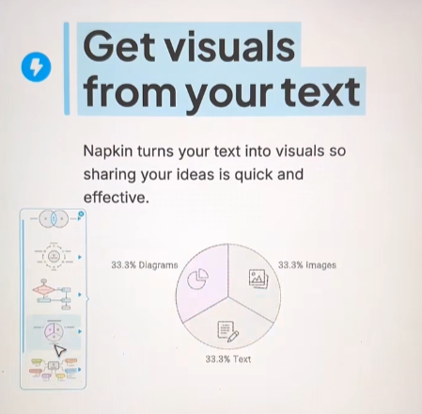
Image-to-vector AI tool | Recraft.ai | Converts images into scalable vector graphics and editable design assets | Upload an image → convert to vector → refine styles → export for UI, logos, illustrations, or branding | image to vector AI, vector generator AI, convert PNG to SVG, AI logo vectorizer, Recraft AI tool | 
Idea-to-app AI tool | AppAlchemy.ai | Turns ideas into functional apps using AI | Describe your app idea → AI generates app structure → refine features → deploy or export build | idea to app AI, AI app builder, no-code app generator, build app from idea, AI SaaS builder, AppAlchemy AI tool | 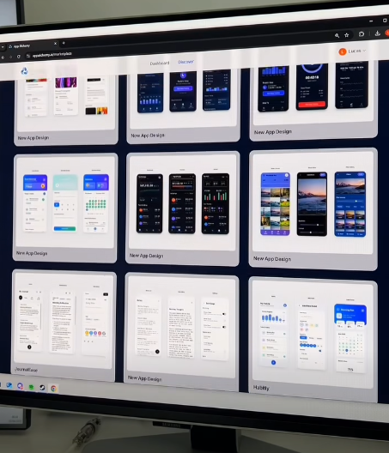
Category | Tool | What it does | How to use / value | Search keywords | Image
Knowledge mapping / learning discovery tool | Learn Anything | Builds visual learning paths and topic graphs to explore any subject | Search a topic → view connected concepts → follow structured learning paths → discover resources and prerequisites | learn anything map, topic graph learning, skill roadmap tool, knowledge graph education, AI learning path generator, self learning map | 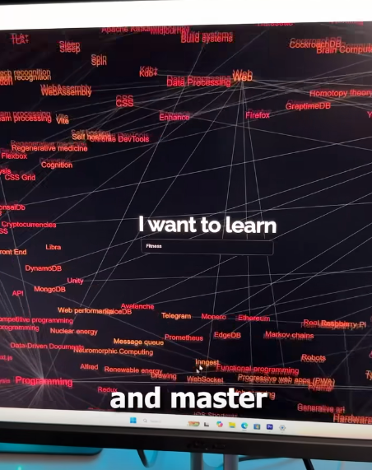

Category | Tool Stack | What it does | How to use / value | Image
High-ticket affiliate side hustle system | Digistore24 + ViralFindr + Pexels | Finds high-commission digital products and helps generate short-form content for traffic and sales | Pick $500–$1000+ offers → add affiliate link to bio → post 5–7 sec viral-style clips → use ViralFindr for winning formats → source clips from Pexels → iterate based on views and clicks | —

Category | Tool Stack | What it does | How to use / value | Image
AI business advisor system | Frederick AI | Acts as a virtual business advisory team with multiple expert perspectives (e.g., marketing, finance, strategy, operations) | Ask business questions or ideas → get multi-expert feedback → compare perspectives → refine decisions faster → use it like a lightweight consulting team for planning, validation, and strategy | 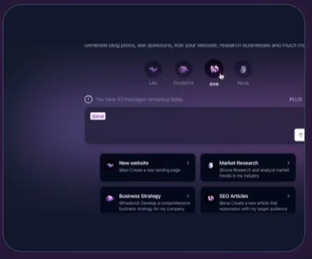
Category | Tool Stack | What it does | How to use / value | Image
Free printable coloring page library | YoPrintables | Provides free downloadable coloring pages and printable designs across different themes | Browse categories → download free coloring pages → print instantly for kids, education, or relaxation → use for activities, classrooms, or low-cost content creation ideas | 

Category | Tool Stack | What it does | How to use / value | Image
UGC content monetization system | TikTok or Instagram + Whop.com | Lets creators earn payouts for driving views and engagement on sponsored content and UGC campaigns | Create a new TikTok or Instagram account → browse Whop “Discover” → filter for UGC campaigns → pick offers with clear payout per views or actions → follow content requirements → post short-form videos consistently → optimize hooks based on performance → drive traffic or engagement back to Whop campaign links → scale by repeating winning formats and doubling down on high-retention videos | 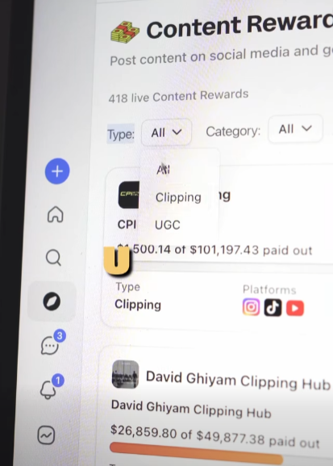

Category | Tool Stack | What it does | How to use / value | Image
AI content automation system | Scade + AI agent builder + social platforms | Builds AI agents that can generate and post content automatically across platforms | Use Scade.pro to build an AI agent → connect it to content sources and prompts → define posting rules (niche, frequency, style) → connect social accounts → automate content creation + scheduling → optionally build a custom AI app interface that controls the agent → scale by refining prompts and engagement loops to improve output quality over time | 

Category | Tool Stack | What it does | How to use / value | Image
Social media data scraping + analysis system | Apify + Julius AI | Scrapes social media data and analyzes performance patterns like posting time, engagement, and content trends | Use Apify pre-built actors to scrape your account + competitors → extract posts, timing, and engagement data → export dataset → upload to Julius AI → run analysis to find patterns (best posting times, high-performing formats, engagement spikes) → apply insights to optimize your content strategy and posting schedule → iterate based on performance improvements | 

Category | Tool Stack | What it does | How to use / value | Image
AI city poster generator | TerranInk | Generates stylized poster artwork based on any city | Enter a city name → AI generates a custom poster design → choose style (minimal, cinematic, vintage, etc.) → refine or regenerate variations → download and use for prints, décor, or digital products → useful for creators selling wall art or building city-themed design products | 

- Sales framework for closing calls
  - Closer Framework (Alex Hormozi style)
Step | Name | What it does | How to execute
C | Clarify | Understand why they’re on the call and what they want | Ask direct questions about goals, problems, and desired outcome
L | Label | Define their problem clearly and accurately | Name their past → current → future state gap in simple terms
O | Overview | Explore past attempts and emotional pain | Ask what they’ve tried, what worked, what failed, and why
S | Sell the vacation | Present solution as 3 core pillars | Explain each pillar in 1–2 lines + use analogy/metaphor to paint outcome
E | Explain away concerns | Handle objections and doubts | Answer questions directly, remove uncertainty, simplify risks
R | Reinforce | Lock in decision and next steps | Confirm purchase decision, outline exact next steps, reinforce confidence

- SEO ranking content system
  - FindQuestions.com + LLM (ChatGPT)
    - Go to FindQuestions.com and type what you sell
    - Pick one real question people are asking
    - Paste it into an LLM using this prompt:
"I’m writing a blog post answering this question: ‘XXXX’.
Ask me anything you need to know in order to make this blog post truly helpful and unique. It should include my experience, expertise, case studies, examples, and insights.
Keep it limited to 10 questions total. Ask them one at a time and wait for my response before moving to the next. I will be answering slowly, so give me time between questions."
    - Answer each question with real experience, examples, and context
    - Use the final responses to generate a high-quality SEO blog post
    - Publish content designed to rank better by combining real search intent + personal expert

- AI-First SEO System
Real questions + real experience + backlinks = SEO that ranks in AI-driven search
  - FindQuestions.com
    - Pull real customer questions from what you sell
    - Pick high-intent queries
    - FindQuestions
  - LLM Blog Workflow
Prompt:
"I’m writing a blog post answering this question: ‘XXXX’. Ask me anything you need to know to make this truly helpful and unique. Include experience, case studies, examples. Ask max 10 questions one at a time."
    - Turn answers into blog post
    - Add experience + examples
    - Add internal links
  - LinkGap.io
    - Compare your site vs competitors
    - Find missing backlinks
    - LinkGap

- SEO: Force Google to Index Your Site - If it’s not indexed → it doesn’t exist in Google.Indexing = first step before ranking
  - Google Search Console
    - Add your website
    - Paste your page URL into “URL Inspection”
    - Click “Request Indexing”
    - Google Search Console
  - Check if Google knows your page
    - Copy your page URL
    - Search: site:yourpageurl.com
    - If nothing shows → Google hasn’t indexed it yet
  - How to force visibility
    - Submit money pages (sales pages, landing pages)
    - Request indexing in Search Console
    - Repeat for new pages after publishing

- SEO Competitor Keyword Gap System - Use competitor data instead of guessing — rank for proven keywords already driving traffic in your niche
  - Ubersuggest (NP Digital)
    - Keyword research + competitor analysis tool
    - Find what competitors rank for that you don’t
    - Identify traffic + SEO opportunities
    - Ubersuggest
    - Cost: Free limited plan + Paid ~$29/month (Pro tier, varies by billing)
  - Keyword Gap Strategy
    - Enter your website + competitors
    - Extract keywords they rank for that you’re missing
    - Focus on high-intent + low-competition keywords
  - Execution
    - Add keywords to existing pages
    - Create new blog posts targeting gaps
    - Optimize titles, headers, and content around them

- Bootstrap App Building System - Build and validate apps with no investors, no paid ads, and minimal upfront cost
Core Rule: Validate first → build fast → keep it 1 feature → optimize monetization → scale what works
  - Idea Selection
    - Find a painful problem affecting a large group of people
    - Focus on “1 feature = 1 core problem” apps only
  - Validation (Market Proof)
    - Use Sensor Tower to analyze existing apps in the niche
    - If competitors are making revenue → market is proven
    - Sensor Tower
    - Check Google Trends for search demand over time
    - Google Trends
  - Build MVP Fast
    - Use Rork to quickly build a simple working version
    - Launch with the minimum possible features
  - Low-Cost Development
    - Hire freelancers on Upwork to refine or finalize the app
Upwork
  - Monetization Optimization
    - Use Superwall to A/B test paywalls, pricing, and offers
Superwall
  - Growth Strategy
    - Use Posted to generate and distribute content for marketing
Scale winning organic content into paid ads
Posted

AI Video Editor (Local LLM Agent System)
video-use (browser-use)
- Open-source AI video editing agent built for Claude Code
- Turns raw clips into a finished final.mp4 using natural language commands
- Uses local pipeline + ffmpeg + transcript-based editing instead of manual timelines
- video-use GitHub
- Cost: Free (open-source)
- Optional cost: ElevenLabs API for transcription (~usage-based pricing, typically pay-per-use)
Agent Workflow
- Drop raw clips into a folder
- Run Claude Code (or similar agent)
- Agent reads transcripts (not full video frames)
- Cuts filler words, trims silence, selects highlights
- Adds subtitles, transitions, and polish automatically
- Outputs ready-to-post video (final.mp4)
Core Idea
LLM doesn’t “watch” video — it reads structured transcripts + edits like code
Result: fast, scalable, automated content editing without timeline tools

